What does this mean?
Alerts personnel of a bomb threat or discovery of a suspicious item while doing a visual scan following a bomb threat.

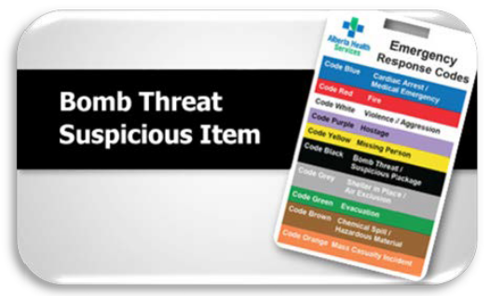
What do I do?
If you receive a Bomb Threat by telephone:
- Remain calm and courteous
- Do not argue
- Do not hang up
- Notify co-worker verbally, or call co-worker by landline telephone (Do not use cellular phones)

If you receive a Bomb Threat during a face-to-face conversation:
- Remain calm and courteous
- Do not argue
- Verbally notify co-worker (by landline phone) while talking to the person if possible (Do not use cellular phones)

If you receive a Bomb Threat electronically (fax, email, text message):
- Remain calm
- Do not reply to, forward, delete or destroy email / text message / fax
- Print email / text snapshot
- Do not use cellular phones to notify anyone, after receiving the threat
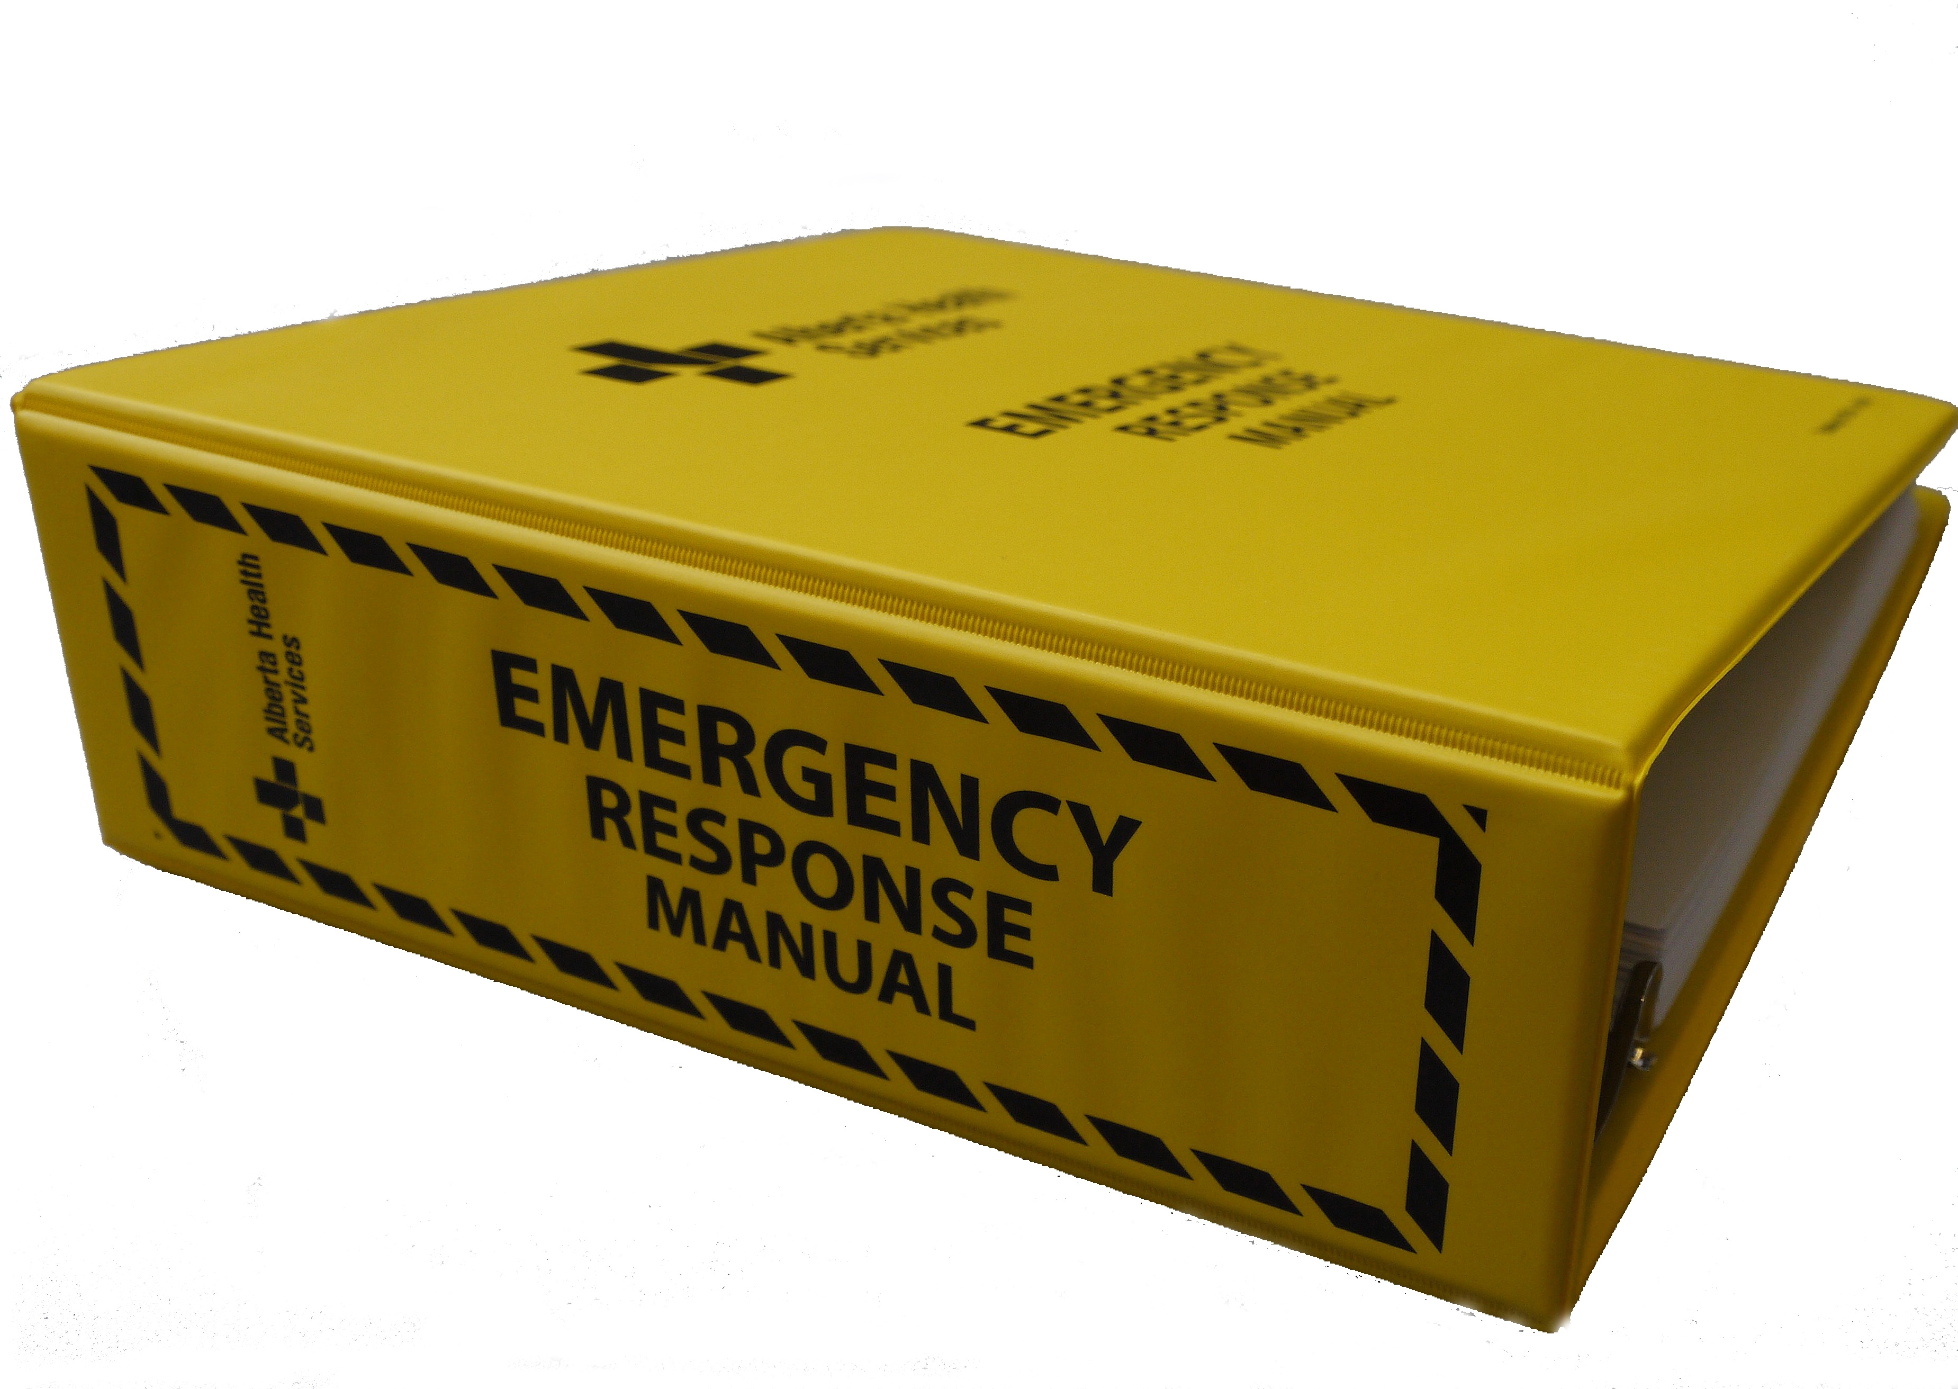

Learn more about Emergency Response Plans
- Refer to your sites Emergency Response Manual
- Refer to your facility’s Emergency Response Plans

