What does this mean?

Alerts staff that a chemical spill has occurred and/or a hazardous substance was released.

What do I do?
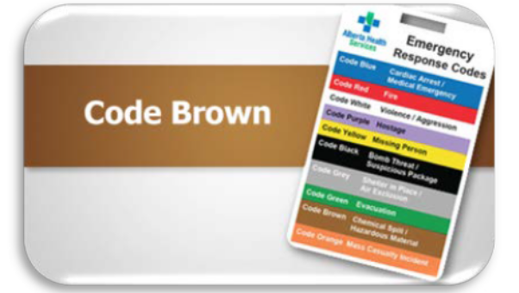
- Clear all individuals from the affected area, if it is safe
- Assume that the spill / release is hazardous
- Provide first aid and clean up according to the product Safety Data Sheet (SDS)
- Notify your supervisor/designate
- Conduct a risk assessment:
  - Identify released substance, obtain the relevant SDS
  - Estimate the quantity / volume of substance released
  - Evaluate the hazards and risks of the substance (flammability, toxicity, corrosiveness, etc.)
- If the spill and/or release is of a KNOWN substance, isolate the spill / release as appropriate to the substance, if it is safe to do so
- If the spill and/or release is of an UNKNOWN substance, isolate the vicinity of the spill / release as best you can achieve, if it is safe to do so
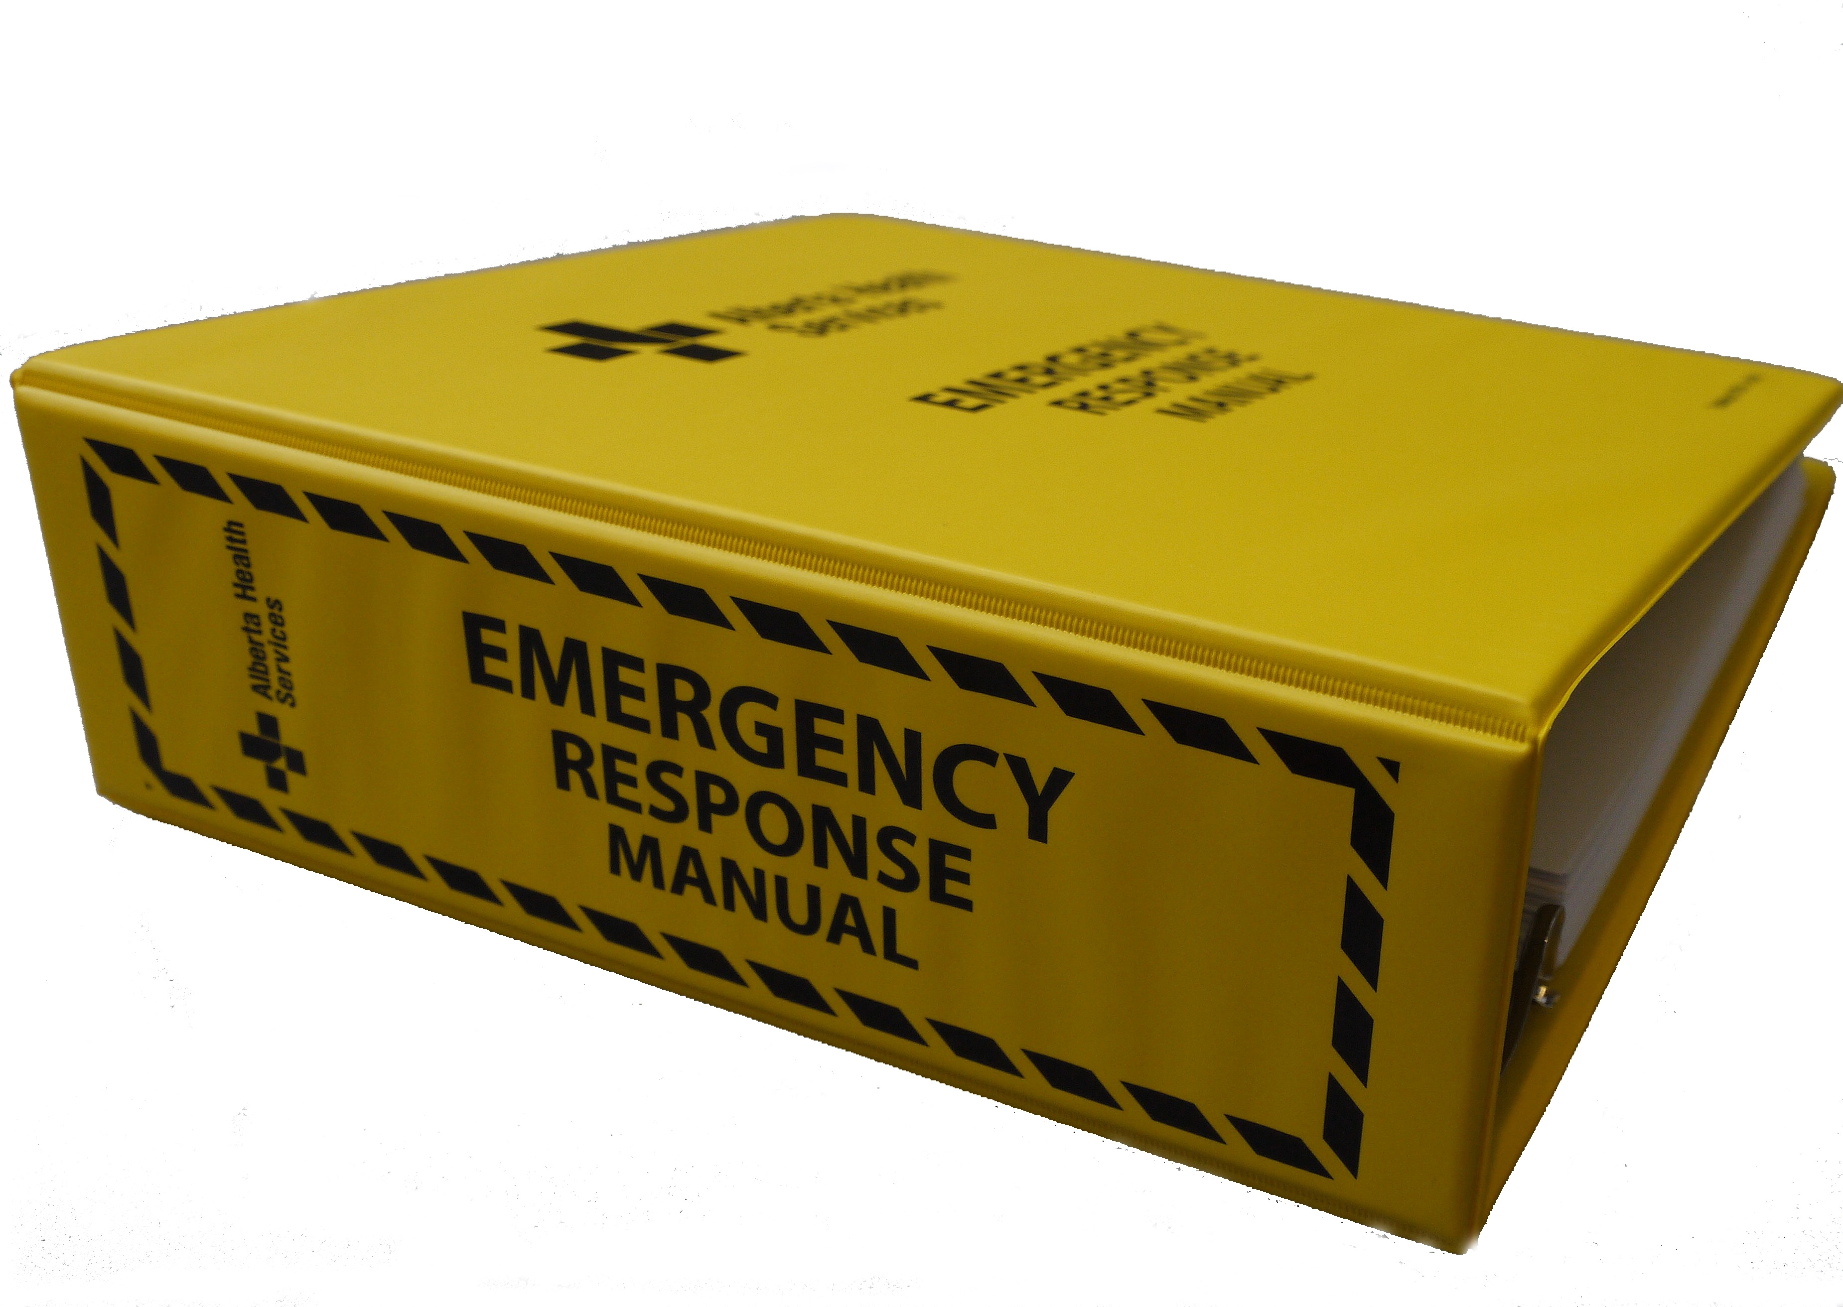
Learn more about Emergency Response

- Refer to your sites Emergency Response Manual
- Refer to your facility’s Emergency Response Plans

More planning / training resources are available
- Identify your site specific training and/or resources you have (WHMIS, practice drills or table top exercises)

