Computer Workstation Ergonomics: Self-Assessment Checklist
The goal of this self-assessment is to help you set up your workstation for optimal comfort and performance.
Item | The Office Chair | Yes | No | N/A | Suggested Action
1. | Can the height, seat and back of the chair be adjusted to achieve the posture outlined below? |  |  |  | - Obtain a fully adjustable chair
2. | Are your feet fully supported by the floor when you are seated?
3. | Does your chair provide support for your lower back?
4. | When your back is supported, are you able to sit without feeling pressure from the chair seat on the back of your knees?
5. | Do your armrests allow you to get close to your workstation?

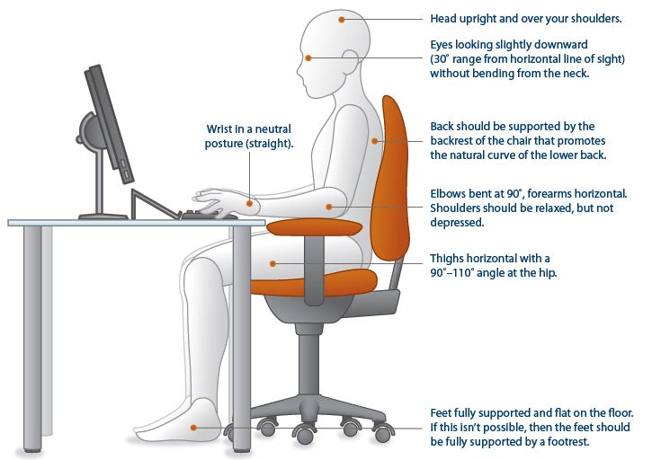
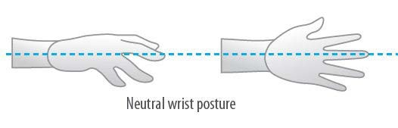

Item | Keyboard and Mouse | Yes | No | N/A | Suggested Action
6. | Are your keyboard, mouse and work surface at your elbow height?
7. | Are frequently used items within easy reach?
8. | Is the keyboard close to the front edge of the desk allowing space for the wrist to rest on the desk surface?
9. | When using your keyboard and mouse, are your wrists straight and your upper arms relaxed? The keyboard should be flat and not propped up on keyboard legs as an angled keyboard may place the wrist in an awkward posture when keying.
10. | Is your mouse at the same level and as close as possible to your keyboard?
11. | Is the mouse comfortable to use?

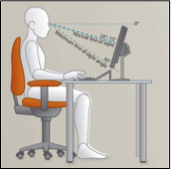

Item | Work Surface | Yes | No | N/A | Suggested Action
12. | Is your monitor positioned directly in front of you?
13. | Is your monitor positioned at least an arm’s length away?  - Note: monitor’s location is dependent on the size of the monitor, the front, screen resolution and the individual user e.g. vision/use of bifocal or glasses etc.
14. | Is the monitor height slightly below eye level?
15. | Is your monitor and work surface free from glare?
16. | Do you have appropriate light for reading or writing documents?
17. | Are frequently used items located within the usual work area and items which are only used occasionally in the occasional work area?

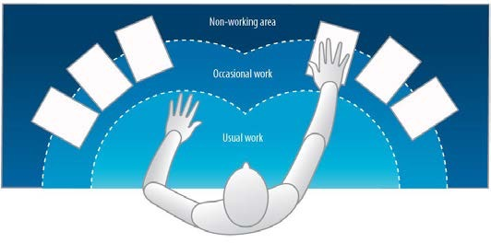

Item | Breaks | Yes | No | N/A | Suggested Action
18. | Do you take postural breaks every 30 minutes? Standing, walking to printer etc.
19. | Do you take regular eye breaks from looking at your monitor?

Item | Accessories | Yes | No | N/A | Suggested Action
20. | Is there a document holder either beside the screen or between the screen and keyboard required?
21. | Are you using a headset or speakerphone if you are writing or keying while talking on the phone?

Person Completing Assessment
Name |  | Position
Signature |  | Date

