Purpose
[Organization name] Is committed to protecting all those working in their work site. Prompt First Aid can reduce the severity and minimize the impact of injuries at [site name]. All incidents occurring at the work site will be reported and investigated to improve the occupational health and safety management system and reported to the appropriate authorities.

Policy
[Organization Name] is committed to ensuring a safe workplace for all parties. To ensure compliance with OHS Code Part 11, First aid provisions are required as identified in Schedule 2 table 6 of OHS Code. [Site Name] will provide a First Aid station/kit and it will be maintained, at minimum, to the standards of any applicable legislation, regulation, code, or standard. The First Aid station/kit will be easily accessible for the prompt treatment of any injury at [insert location here]. [Site Name] will ensure that the site is manned with trained first aiders to a minimum outlined in Schedule 2 of the Alberta OHS Code. [unless granted an agreement with the Director of Medical Services s177(1).

[For seniors supportive living consider inserting policy on providing first aid for residents]

Definitions
- First Aid: means the immediate and temporary care given to an injured or ill person at a work site using available equipment, supplies, facilities or services, including treatment to sustain life, to prevent a condition from becoming worse or to promote recovery.
- First Aider: means an emergency first aider, standard first aider or advanced first aider designated by an employer to provide first aid to workers at a work site.
- Emergency First Aider: means a person who holds a certificate in emergency first aid from an approved training agency.
- Standard First Aider: means a first aider who holds a certificate in standard first aid from an approved training agency.

Responsibilities
- Manager/supervisor is responsible for ensuring that the appropriate number of staff are trained and on duty. Providing first aid supplies as required by legislation. To pay for transport if an injured worker requires further medical assistance beyond first aid. Must ensure proper external reporting of disabling injuries to WCB and serious or potentially serious incidents to OHS.
- Workers are responsible for reporting all incidents, including near misses.

Procedure
- In the case of an occupational injury or sudden illness at the work site, the manager/supervisor will ensure immediate first aid. Paige the designated first aider to the location.
- The designated first aider will administer first aid as required.
- If the first aider assesses the need for further treatment the manager/supervisor will call 911 for emergency treatment or;
  - If [site name] participates in WCB Occupational Injury Service, the manager/supervisor may contact the OIS clinic of choice and arrange transport for the injured/ill worker.
- First Aider completes the First Aid Record [either a stand-alone form or part of Incident Record]
- Manager/supervisor completed Incident Record and follows investigation procedures outlined in [insert policy reference for element 9 Incident Investigation]

Forms/Appendixes
- First Aid Record – see Incident Record
- Type 1 First Aid Kit Inspection Checklist
- Type 2 First Aid Kit Inspection Checklist
- Type 3 First Aid Kit Inspection Checklist
- Type P First Aid Kit Inspection Checklist
Code Schedule 2 – Table 6
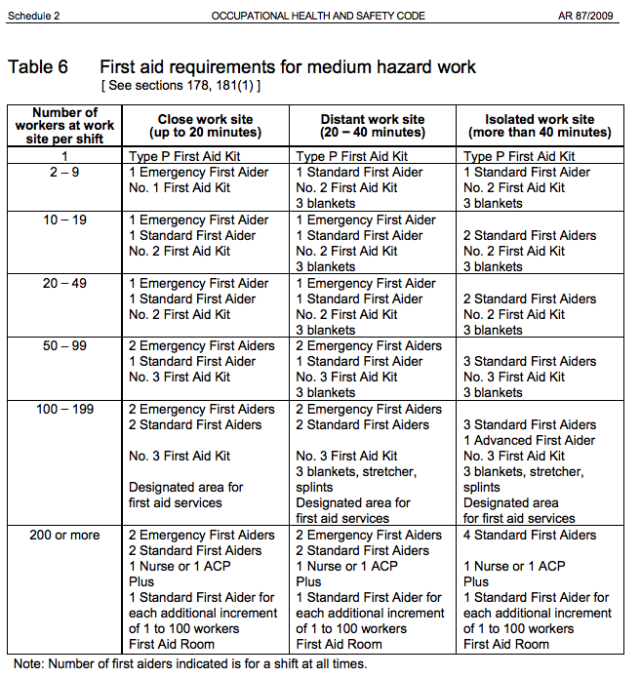

References

Occupational Health and Safety. Act, Regulations and Code Handbook. January 2020

