What does Mass Casualty Incident mean?
It alerts and notifies staff of the need to prepare for or respond to anticipated casualty volumes which are likely to exceed Site available resources, requiring additional or extraordinary assistance, or may require multi-site responses (Mass Casualty Incident).

What do I do?
Your area’s role and response to a Mass Casualty Incident declaration will vary, depending on the support needed, and the scale of the incident. Code Orange may be activated as follows:
- MASS CASUALTY INCIDENT STANDBY is activated when there is a possible or actual incident which has the potential to overwhelm several services at a site. STANDBY may be activated at any one or more sites independently
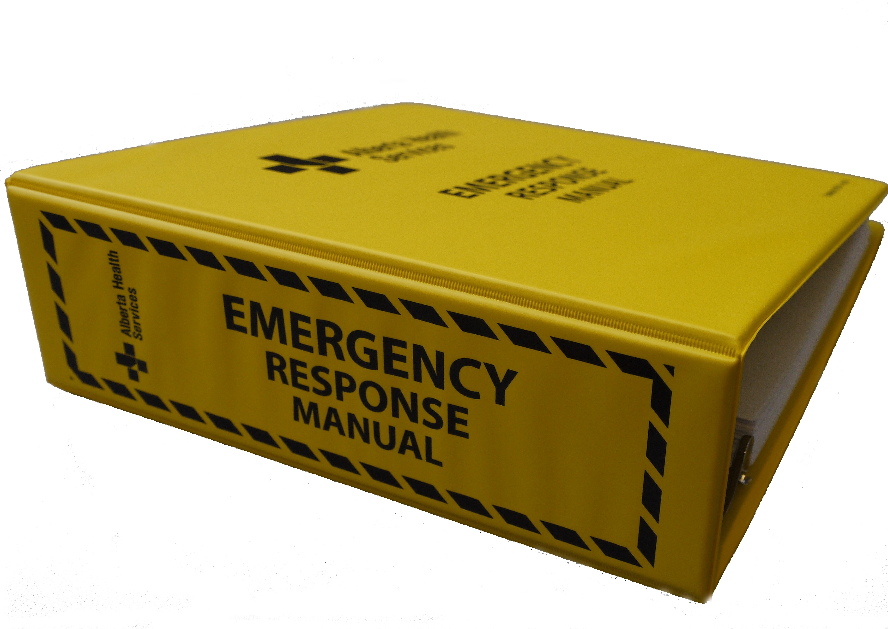
- MASS CASUALTY INCIDENT DECLARED is activated when there is an actual confirmed incident which has occurred that is anticipated to overwhelm several services at a site. This may be DECLARED at one or more sites while other Sites remain on STANDBY
Review it before you need it
- Locate the Site Emergency Response Manual and review the Mass Casualty Incident plan that describes your area’s role if a Mass Casualty Incident is declared

