What does this mean?
Medical Emergency Response alerts personnel and provide clear direction on how to respond to any person experiencing acute physiologic compromise, airway threat, respiratory and / or cardiac arrest.

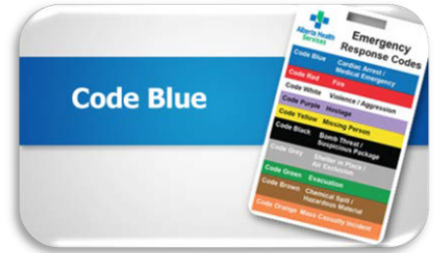
What do I do?
- Staff are responsible to support the arrival and ongoing care of the First Aiders / EMS.
- If indicated, perform basic life support (BLS), including establishing an airway with equipment as available until EMS arrives.
- Direct EMS to the location of the patient.
- Assist as directed throughout the resuscitation.
- Ensure the client’s medical records are in the room.
- Clear any excess equipment or supplies; assist other patients to move away from the area
- Contact the family and attending physician (if not already present).

Review it before you need it:
- Ensure that staff have Basic First Aid and CPR training as per legislation
- Familarize yourself with any equipment and it’s location
- Know how to alert others either by call bell, overhead page, voice etc.
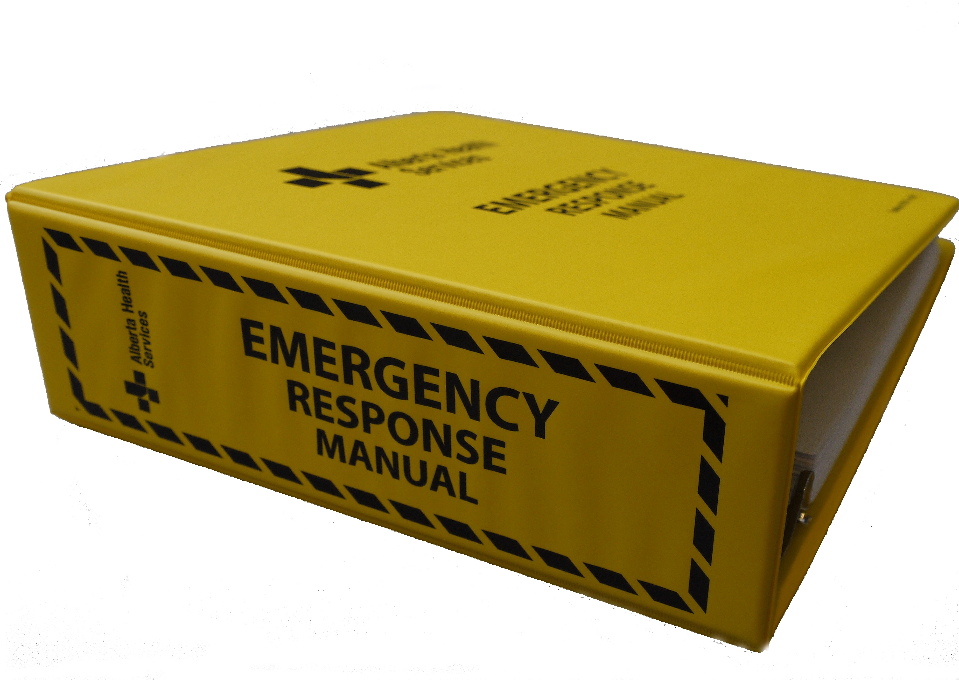
Learn more about Medical Emergencies
- Refer to your sites Emergency Response Manual
- Refer to your facility’s Emergency Response Codes

