What does Shelter in Place / Air Exclusion mean?

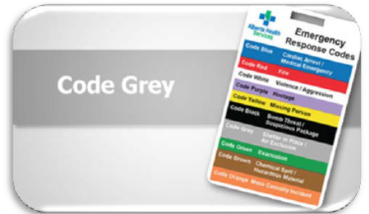
Shelter in Place alerts and notifies staff of the need to reduce the movement of air into and out of the building when there are air quality concerns, potentially from a release of a toxic or hazardous substance in the environment.

What do I do?

- Shelter in Place is activated by Site Administration / Manager in conjunction with the Medical Officer of Health
- Close all doors and windows and, when advised, turn off all fans and the ventilation system.
- Monitor clients and watch those around you for any signs of respiratory distress.
- Report any issues to your supervisor.
- Be prepared to evacuate.
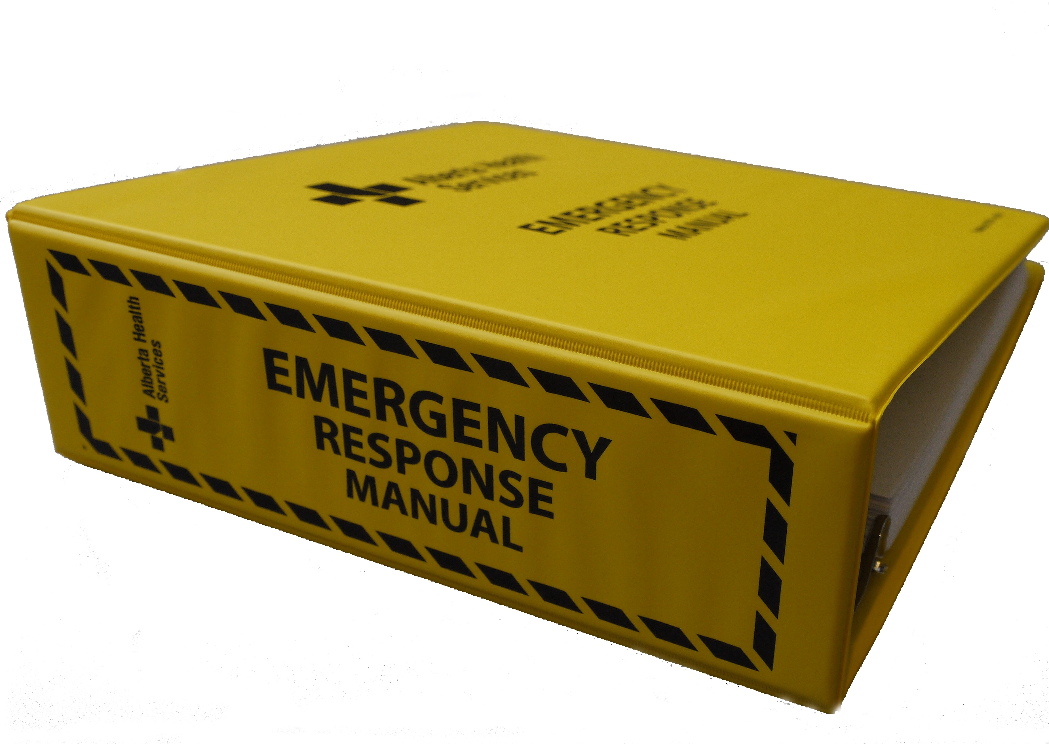
Review it before you need it
- Locate the Emergency Response Plan Manual and review the Shelter in Place / Air Exclusion plan that describes your area’s role if an emergency is declared
- Shelter in Place (seek safety/shelter within the building you already in) has been demonstrated to be the most effective response during the first few hours of an air quality concern, until the hazard has passed.

