What’s been happening since I last visited?  It’s been a long time since I’ve seen my friend or family member. What changes might they have gone through since I saw them last?  Type your response to the question above. Write from the perspective of the organization and position your answer in a positive light while remaining truthful.  What has my friend or family member been doing for fun?  Type your response to the question above. Write from the perspective of the organization and position your answer in a positive light while remaining truthful.  What kind of personal care and attention has my friend or family member been receiving?  Type your response to the question above. Write from the perspective of the organization and position your answer in a positive light while remaining truthful.  Who can I talk to if I have more questions about what’s been going on since I visited last?  Type your response to the question above. Write from the perspective of the organization and position your answer in a positive light while remaining truthful.  Have more QUestions?  If your question was not answered here, please contact us and we will be happy to help.  Telephone  Email | COVID-19 Precautions  Have your staff been vaccinated?  Type your response to the question above. Write from the perspective of the organization and position your answer in a positive light while remaining truthful.  How are you screening visitors for COVID-19?  Type your response to the question above. Write from the perspective of the organization and position your answer in a positive light while remaining truthful.  What infection prevention precautions are in place to keep my friend or family member safe?  Type your response to the question above. Write from the perspective of the organization and position your answer in a positive light while remaining truthful.  Are you prepared for a future wave or outbreak of COVID-19?  Type your response to the question above. Write from the perspective of the organization and position your answer in a positive light while remaining truthful.  Who can I talk to if I have more questions about COVID-19 precautions?  Type your response to the question above. Write from the perspective of the organization and position your answer in a positive light while remaining truthful. | VISITATION  FAQ  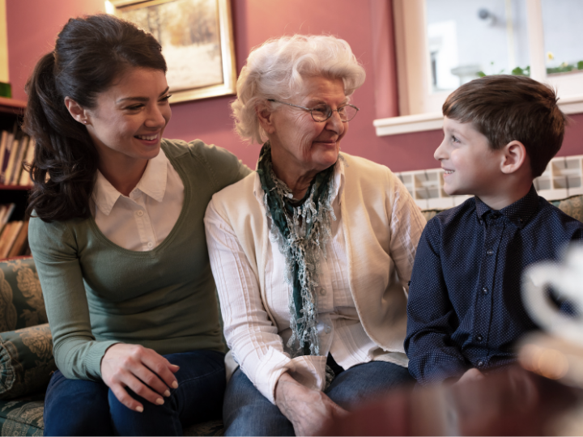  Now that visitation restrictions are relaxing you must have lots of questions. This pamphlet will help by answers some of the most common questions we get about visitation.  Organization Name  Address, city  Released mm/dd/yyyy
My Visit  My friend or family member moved in while visits were restricted, and I’ve never been inside. Can I set up an orientation or tour?  Type your response to the question above. Write from the perspective of the organization and position your answer in a positive light while remaining truthful.  Do I need a vaccination to visit? What if I have not been vaccinated?  Type your response to the question above. Write from the perspective of the organization and position your answer in a positive light while remaining truthful.  Do I need to wear PPE during my visit? What PPE do I need to wear?  Type your response to the question above. Write from the perspective of the organization and position your answer in a positive light while remaining truthful.  What hand hygiene and social distancing rules do I have to follow?  Type your response to the question above. Write from the perspective of the organization and position your answer in a positive light while remaining truthful. | my visit  How long can I visit for? How often can I visit?  Type your response to the question above. Write from the perspective of the organization and position your answer in a positive light while remaining truthful.  How many people can visit at the same time?  Type your response to the question above. Write from the perspective of the organization and position your answer in a positive light while remaining truthful.  Where will our visit take place? Can we visit in my friend or family member’s room?  Type your response to the question above. Write from the perspective of the organization and position your answer in a positive light while remaining truthful.  Can I touch or hug my friend or family member?  Type your response to the question above. Write from the perspective of the organization and position your answer in a positive light while remaining truthful.  Can I help provide care to my friend or family member?  Type your response to the question above. Write from the perspective of the organization and position your answer in a positive light while remaining truthful.  Can I take my friend or family member for a walk? Can we go outside or off the grounds?  Type your response to the question above. Write from the perspective of the organization and position your answer in a positive light while remaining truthful. | my visit  Can I take my friend or family member home for a few hours?  Type your response to the question above. Write from the perspective of the organization and position your answer in a positive light while remaining truthful.  Can I bring my pet when I visit?  Type your response to the question above. Write from the perspective of the organization and position your answer in a positive light while remaining truthful.  Can I bring gifts or treats for my friend or family member? May I hand it to them directly?  Type your response to the question above. Write from the perspective of the organization and position your answer in a positive light while remaining truthful.  Who can I talk to about my friend or family member’s cognitive or physical condition?  Type your response to the question above. Write from the perspective of the organization and position your answer in a positive light while remaining truthful.  Who can I talk to if I have questions about visitation parameters?  Type your response to the question above. Write from the perspective of the organization and position your answer in a positive light while remaining truthful.

