Documentation Request Checklist
2022 Audit; COR Recertification Audits (completed by an external auditor) and COR Maintenance Audits (completed by an internal or external auditor) minimum requirement is documentation and interview:
- Documentation review for documentation and interviews, the minimum requirement for a three-year COR will be any six months of documentation in the previous 12 month period. Auditor will identify months of documentation in the elements.

In order to assist organizations with the remote audit process the following documentation checklist and document organization suggestions have been created for you.
Below is a screen shot example of how you may want to organize documents for ease of data gathering
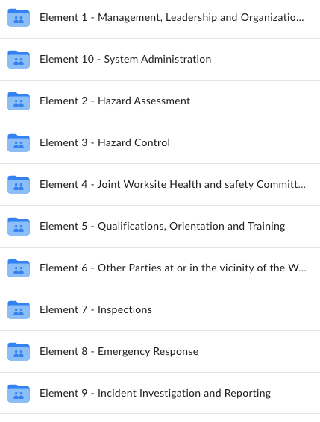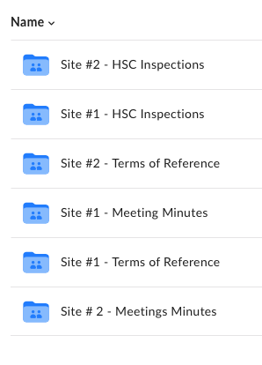

Element Documentation Checklist
Element 1: Leadership and Organizational Commitment
Signed Health and Safety policy
Documents where written statement of responsibilities/accountabilities are included for all levels. (ex. job descriptions, employee contracts, employee manuals, staff handbooks
Meeting minutes where H&S is a standing agenda item and where management/supervisory staff have participated. Examples could be: department meetings, town halls, general staff meetings, health and safety meetings. [auditor specify months required]
Element 2: Hazard Assessment
Current organizational chart or job inventory list (used to compare number of positions and the number of documented Hazard Assessment documents)
Hazard assessment policy/process (may also be referred to as formal hazard assessments, job safety analysis, etc.)
Completed Formal Hazard Assessments for all positions (if different for each site/location, then employer to provide)
Training documents for staff members designated to lead the creation and/or review of formal hazard assessments
Site specific hazard assessment policy/process (also called Field Level Hazard Assessments)
- When a new activity has been temporarily introduced at the work site (ex. new policy/procedure, new equipment).
- Work is conducted at a temporary/mobile work site (ex. if facility needed to evacuate their building would they go to another building, resident outings)
- Copy of blank site specific form
Completed site-specific hazard assessments for above listed possible scenarios
Element 3: Hazard Controls
Documents demonstrating the implementation of administration controls listed in formal hazard assessments (ex. Safe Work Procedures/Policies (SWPP), training documents, memo’s, meeting minutes, etc.)
Documents outlining the preventative maintenance policy and process for building, vehicles, equipment, and tools.
Preventative maintenance records, completed scheduled work documents, work order records, etc. specific to preventative maintenance. This includes any contracts with other work site parties who complete regular PM.
Violence Prevention Plan including policies and procedures
Harassment Prevention Plan including policies and procedures
Element 4: Health and Safety Committee/HS Representative
HSC and/or HSR policies and/or procedures, terms of reference
HSC member lists and HSR information (current for the timeframe of documents provided)
Written statement of the HSC and/or HS representative duties and responsibilities (if not on the TOR)
Policy or procedure for HSC/HS rep to address employee concerns related to OHSMS
Training documents for members/representatives (includes internal training and mandatory HSC Co-chair(s) training - copies of actual certificates)
Health and safety committee meeting minutes [auditor specify months required]
HSC related documentation that supports corrective action completed in a timely manner by the HSC, e.g. feedback forms, emails, HSC meeting minutes, communications, etc. [auditor specify months required]
Element 5: Qualifications, Orientations and Training
Orientation policy and process including any checklists, orientation package/contents (blank samples)
Policies, procedures and documents that describe how the employer ensures employees are qualified for position they are being considered for. (ex. hiring policy, hiring checklist, HR hiring practices etc.) (blank samples)
If the organization tracks employee training and orientation on a spreadsheet this can be provided to the auditor to verify the following:
Policies, procedures and documents that describe the orientation information given to newly hired employees
Department/job specific training (blank) (ex. buddy checklist, department orientation checklists)
Job-specific training when they are a new employee, assigned a new task or when an operational change affect their work. These can be blank samples of checklists, competency, as well as completed samples which verify training when assigned a new task or changes that affect their work.
Completed competency assessments (return of skill demonstrations) (ex. Donning and doffing PPE, hand hygiene audits, demonstrations of proper equipment/technique demonstrations)
Refresher/Annual Mandatory Training documents such as checklists, in-house training, policies etc. If the employer tracks annual training on spreadsheet, this can be provided as well.
Training completed for managers and supervisors (specific to support them in their role)
Element 6: Other Worksite Parties at or in the Vicinity of the Work Site
Policy and/or process to address the protection of others not under the employer’s direction. (blank documents; completed documents not required)
Policy, and/or process documents for hiring, evaluating and selecting contractors, other employers and/or self-employed persons. (blank documents; completed documents not required)
Policy and/or process for monitoring other work site parties while they are on site working. (blank documents; completed documents not required)
Process for non-compliance of other employers and/or self-employed persons at the work site.
Orientation checklist, orientation package/contents for visitors, family members, other employees and/or self-employed persons.
Copy of completed other work site parties orientation (visitors/volunteers this could be sign in sheets with information as to what is available for them to review when entering building – hand washing, outbreak, fire procedure etc.)
Element 7: Inspections
Inspection policy and procedure documents (schedule, blank checklists, etc.)
Training documents for staff members designated to lead the inspection process
Completed Inspection checklists and inspection reports (if separate) [auditor specify months required]
Element 8: Emergency Response
Emergency response and evacuation plans, policies, and procedures
Documents relating to emergency response drills, such as records of drills, minutes for drill review meetings, table-top exercises, etc. [auditor specify months required]
Documents relating to actual emergency responses, such as records of response, minutes for response review meetings, documents outlining corrective actions or changes in procedure and documents that show corrective actions were completed (if on the form or training records, memo’s, maintenance requestions) [auditor specify months required]
Schedule or worker rotation records (required for verification of first aid on all shifts)
Training of employees in first aid (copies of actual certificates or spreadsheet indicating training is up to date)
Element 9: Incident Investigations
Incident reporting and investigating policy/process for incidents, illness, near misses and work refusals. (these many be separate or combined policies and processes).
Completed Incident forms (incident, root cause, corrective action, dates from start of incident to completion of investigations for incidents, illness, near misses and work refusals. [auditor specify months required]
Completed investigation report forms, memos, meeting minutes, work orders etc. regarding implementation of corrective actions, minutes of meetings discussing investigations. [auditor specify months required]
Training documents for employees designated to lead investigations
Element 10: System Administration
Organization specific monthly, quarterly, or annual health and safety reports, injury report analysis, health and safety statistics and trend reports
Previous health and safety system evaluations and action plans (with completion details)

Thank you for providing all relevant documentation. Please note that the auditor may request additional records or documents if applicable.

